Pete’s 737

A project originally of David Proud. Picked up in 2011.

Shifted, Shortened, strengthened, rust ground out, and repainted.

Real Sound - http://www.mycockpit.org/forums/content.php/351-NEWS-RELEASE-FSPS-Real-Cockpit-Sound

Radio Modules

Open Cockpits COM1, Com2

Goflight MCP Professional

MCP OpenCockpits - <http://www.opencockpits.com/catalog/mcp-737ng-v2-p-110.html> - 345 Euro

MIP - http://www.simworld.pl/shop/product_info.php?cPath=1_4_10&products_id=36

Open Cockpits – Annunciators for Forward Panel - 1 x Overhead -FWD- indicators with leds 189.00EUR

Open Cockpits – Rudder Trim Panel 1 x Rudder Trim indicator with panel 139.99EUR

Data Entry Screen –

USBKeys Card <http://www.opencockpits.com/catalog/usbkeys-card-p-53.html?cPath=21_35> - 24 Euro

Throttle Quadrant – Sim Revolutions

MIP –

To Purchase

What’s needs purchasing:

1. Aft Panel
2. Speakers for sound
3. Ground steer in FSUIPC need for tiller
4. Replace base on both seats

Available Components

Purchased Components highlighted.

|  | Fly Engravity | SimWorld | glb | Flight Deck Solutions | Open Cockpits |
| --- | --- | --- | --- | --- | --- |
| Forward Overhead Panel | 549E |  | 485gbp | 1800cad |  |
| Forward Overhead Panels and frame |  | 617E |  | Frame onlt 450cad |  |
| Switches and Electronics for Forward Overhead Panel |  | [1] |  |  |  |
| Aft Overhead Panel |  |  |  |  |  |
| Overhead Annunicators |  |  |  |  |  |
| Gauges for overhead Panel |  |  |  |  |  |
| Mcp | 999E |  |  |  |  |
| Mcp el | 499E |  |  |  |  |
| 6 Pack recall | 79.95 |  |  |  |  |
| AFDS |  |  |  | 60cad |  |
| MIP Interface board | 199 |  |  |  |  |
| Clipboard |  |  | 35gbp |  |  |
| Landing Gear Lever | 199E[2] |  | 139gbp | 280cad | 134E |
| Tiller |  |  |  |  | 182E |
| MIP Frame Central |  | 105.9E |  |  |  |
| MIP Frame Lower |  | 73.17E |  |  |  |
| MIP Frame FO |  | 121.95E |  |  |  |
| MIP Frame CPT |  | 121.95E |  |  |  |
| MIP Annunciators |  | 27.64E[3] |  |  |  |
| Fly Engravity Glare Wings |  |  |  |  |  |
| Needed Switches for overhead and other panels. | 289E (toggle) |  |  |  |  |
|  |  |  |  |  |  |
| Audio panel pair | 399E |  |  | 350cad, single |  |
| Efis pro | 299E |  |  |  |  |
| Efis | 199E |  |  |  |  |
| Master Caution Switch | 41E |  |  |  |  |
| Fire Warn Switch | 41E |  |  |  |  |
| Dzus replic |  | 10 for 5E | 8 6.5gbp |  |  |
| 128 input card for overhead |  |  |  | 250cad |  |

Seat Cushions attached

Glareshields

Software Add-ons

Aerosoft

Modify Fire Handles

Interface Modules

N * Leo Bodnar 32 Input card – switch and rotary input

<http://www.leobodnar.com/products/BU0836X/>

N * Leo Bodnar Analog interface card for temp throttle and steering tiller. 8 Analog inputs

<http://www.leobodnar.com/products/BU0836/>

Output Interface modules

Back to Phidgets

64 Port Led module – consideration of swapping what is in F16 pit ultimately

<http://www.phidgets.com/products.php?category=15&product_id=1031> - CAD$125

Servo Output for overhead Panel gauges, 8 Port

<http://www.phidgets.com/products.php?product_id=1061> - CAD$90

Analog Output

<http://www.phidgets.com/products.php?category=0&product_id=1002> - 4 Outputs - CAD$90

J-Rails for seats from Sim Revolution.

The CPFlight Kit

One thing to be very careful about is the polarity of the PSU connectors for the MCP737EL and the other CPFlight devices. For some tragic reason the polarity of the 6V connector is different. For the MCP the positive is on the outer ring, where as for the other devices the positive is on the inner ring.

Options not currently used – 737 Yoke from

Suppliers

POLDRAGONET – No response from enquiry email

Sim Revolution – can be hard to get a hold off, good once engaged.

Open Cockpits - <http://www.opencockpits.com/>, good response, timely deliveries. EFIS on front page was different to what was ordered.

Systems Overview

Sim-Revolution Throttle

MIP – Sim Engravity MCP, EFIS, MIP Interface, Open Cockpits Servo Controller, Flight Illusions Clock

Forward Overhead – Flight Deck Solutions I/O, Open Cockpits Servo Controller, Open Cockpits Electrical Display

Centre Pedestal – Sim Engravity Radios, Fire Warn.

Control Input

The Sim Revolution Throttle has its own USB interfaces. Other analog control inputs are connected to a Leo Bodnar High Resolution input, with some of the inputs pre-amplified.

Rudder (shared)

Elevator (shared)

Aileron (shared)

Tiller

Led Bodnar USB Input

Amp

Amp

Captain Right Toe Brake

Captain Left Toe Brake

Overhead I/O Card

The FDS-SYS1X High Capacity interface card is designed to deliver the ultimate in interface power with a great deal of simplicity and intuitiveness. The Large capacity of the FDS-SYS1X card makes it ideal for any medium to large project/setup. (128 Switch Inputs and 256 LED Outputs) The SYS software is designed to make interfacing as simple as importing a function, simple search methods, FSUIPC, FS Direct, SIM-A, PM Systems, AST etc. As the user group expands so does the power of the interface. A dedicated Server for importing commands is now on line and slowly building up an inventory of imports. Highly Intuitive Interface System Features:

• Powerful Software For Simplified Configuration

• "Import" Feature for super ease of use and Config Sharing

• FS, PM Systems, Project Magenta, FSUIPC Ready

• 128 Switches

• 256 LED Outputs

Choice of Avionics Suite

Whilst FSUIPC offers a universal interface for Flight Sim X, it doesn’t provide inputs and outputs for everything needed on the Sim (although the gap is decreasing). There are a number of Avionics Suits in the Market. Some such as the Australia SimAvionics provide rich capabilities but only for a captains set of instruments. This Sim is made up of components from several vendors:

1. Flight Deck Solutions for Aft Overhead
2. Fly Engravity for Radio and Front MIP
3. Sim Revolution Throttle
4. Open Cockpits for General Servo

This means the avionics suite needs to be multi vendor aware. Another interesting twist to the possible solution is Fly-NG now offers a pit builders interface natively in its 737 Sim software.

Of the vendors out there three appear to offer reasonable support:

1. The Project Magenta
2. Flight Deck Solutions Sim-A
3. Pro-Sim.

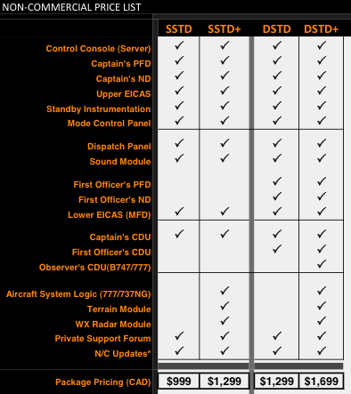

Support Matrix

|  | FSUIPC | PMDG 737-NG | iFLY | Project Magenta | Sim-Avionics | ProSim737 |
| --- | --- | --- | --- | --- | --- | --- |
|  |  |  |  |  |  |  |
| Prepare3d |  |  |  |  |  |  |
| Fly Engravity MCP |  |  |  |  |  |  |
| Fly Engravity MIP  (Master Caution, Firewarning, Six Pack Recall, AFDS), Speedbrake |  |  |  |  |  |  |
| Fly Engravity Capt EFIS |  |  |  |  |  |  |
| Fly Engravity FO EFIS |  |  |  |  |  |  |
|  |  |  |  |  |  |  |
| Open Cockpits Servo | Scripting? |  |  |  |  |  |
| Phidgets Led 64 |  |  |  |  |  |  |
|  |  |  |  |  |  |  |
| Flight Deck Solutions 128in |  |  |  |  |  |  |
|  |  |  |  |  |  |  |
| Capt Screen |  |  |  |  |  |  |
| FO Screen |  |  |  |  |  |  |
| Centre Screen |  |  |  |  |  |  |
| Lower Screen |  |  |  |  |  |  |
|  |  |  |  |  |  |  |

Wiring Diagrams

Fly Engravity Six Pack

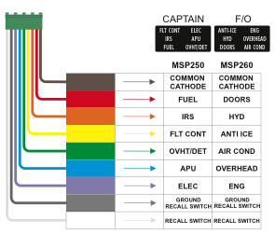

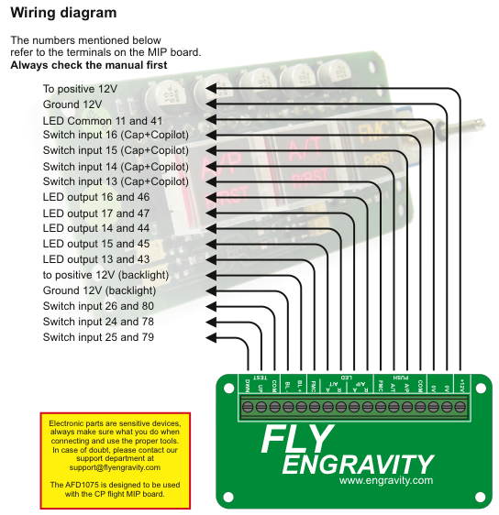Appendix

Avionics S/W

**PROJECT MAGENTA**

**MCP**

All MCP functions are supported by Project Magenta MCP

Project Magenta MCP have on board the driver to communicate with all CPflight harware so you have not to activate FS_COM together to PM MCP

There are two configuration line into MCP.ini file to configure PM to work with CPflight hardware ( one to select the communication port and one to enable the external input/output of MCPEX1)

Please read carefully **http://www.cpflight.com/sito/dettagli/pm.asp** before set PM MCP.ini file

If you use the MCPEX1 board remember to copy the file with txt extension by cpflight folder to Project Magenta MCP folder

The hardware send the command to the MCP of PM and wait a feed back from the software because the hardware don't know the real flight condition

So if you have some doubt about some function that is not engaged by PM please try to select with the mouse the function that give you the problem (probably also with the mouse PM will not accept the command). This is a very important test to make **ever** before contact the CPflight support

For any doubt test ever the hardware with TestCPflightHardware.exe program

If with TestCPflightHardware the hardware work correctly meant that there is no hardware failure, but the problem is only inside to the software that don't accept the command. Please check your flight condition

**EFIS**

All EFIS functions are supported by Project Magenta MCP You can see the EFIS selection on PM PFD display Project Magenta support both the EFIS ( CP and FO side ) Select CP or FO side into Project Magenta PFD setting

**RADIO**

Radio modules are compatible with Project Magenta MCP

**MIP**

MIP board is fully compatible with PM Overhead function annunciator (ELEC, APU... ) work only if you have PMSystem also

**PMDG 737 and 747**

**MCP**

All MCP, Efis, Radios functions are supported by PMDG 737 600/700/800/900 and PMDG 747 through the **flightsimlabs** dedicated driver (payware) This try-before-you-buy downloadable driver provides a fully working, area-limited (around Greece's Venizelos airport) version which can become fully enabled by purchasing a

license key. Also all MIP functions managed by PMDG panel work correctly with the flightsimlabs driver.

Download and install **flightsimlabs** driver on your PC. After run FS and into FSlabs menu select the com port used to communicate with CPflight hardware. Then click on connect button to start.

You can test the driver around the Atene airport. If you decided to buy the driver to flight in all the world you have to provide the hardware serial number (number showed by the MCP in Course1 and IAS display at start-up ). The hardware send the command to the MCP of PMDG (both 737 than 747 ) and wait a feed back from the software because the hardware don't know the real flight condition

So if you have some doubt about some function that is not engaged by PMDG please try to select with the mouse the function that give you the problem (probably also with the mouse PMDG will not accept the command). This is a very important test to make **ever** before contact the CPflight support

For any doubt test ever the hardware with TestCPflightHardware.exe program

If with TestCPflightHardware the hardware work correctly meant that there is no hardware failure, but the problem is only inside to the software that don't accept the command. Please check your flight condition

**EFIS**

All EFIS functions are supported by PMDG 737 600/700/800/900 and PMDG 747

**RADIO**

All Radio modules are compatible with PMDG 737 and PMDG 747

**MIP**

All MIP functions managed by PMDG panel work with MIP board

**DEFAULT FS737**

**MCP**

MCP hardware support all function present on MCP of FS737 default

LNAV, VNAV, CWSA, CWSB and FD2 are not supported. You can assign different function to this button and switch using MCP_CONF program

To communicate with DEFAULT FS737 you have to use the CPflight driver FS_COM.exe

The hardware send the command to FS_COM and wait a feed back from the software because the hardware don't know the real flight condition. FS_COM read the DEFAULT FS737 MCP data status before give a feed back to the hardware

So if you have some doubt about some function that is not engaged by DEFAULT FS737 MCP please try to select with the mouse the function that give you the problem ( probablyalso with the mouse PM will not accept the command).This is a very important test to make **ever** before contact the CPflight support For any doubt about hardware functionality test ever the MCP with TestCPflightHardware.exe program.

If with TestCPflightHardware the hardware work correctly meant that there is no hardware failure, but the problem is only inside to the software that don't accept the command. Please check your flight condition

All FSX EFIS functions are supported With previous version of FS only the Altimeter Pressure

**RADIO**

Radio modules are fully compatible with DEFAULT FS737

**MIP**

MIP board is partially compatible with DEFAULT FS737 Please refer to this link **http://www.cpflight.com/sito/dettagli/mip_fs.asp** to know the the MIP functions that work with DEFAULT B737

**SIM-AVIONICS**  
**MCP**

All MCP functions are supported by Sim-Avionics

Sim-Avionics Software have on board the driver to communicate with all CPflight harware so you have not to activate FS_COM together to Sim-Avionics Software

The hardware send the command to the Sim-Avionics Software and wait a feed back from the software because the hardware don't know the real flight condition

**EFIS**

All EFIS functions are supported by Sim-Avionics SOFTWARE

Sim-Avionics support both the EFIS (CP and FO side)

**RADIO**

Radio modules are compatible (frequency selection) with Sim-Avionics

**MIP**

MIP board is compatible with Sim-Avionics

**PMDG 737NGX**

**MCP**

All MCP functions are supported by the driver The hardware send the command to the PMDG737NGX software and wait a feed back readind the NGX variable status

**EFIS**

All EFIS functions are supported by the driver The driver support both the EFIS ( CP and FO side )

**RADIO**

Pedestal modules are compatible with PMDG737NGX

**MIP**

MIP board is compatible with PMDG737NGX

**iFly737**

**MCP**

All MCP functions are supported by the driver The hardware send the command to the iFly737 (both FS9 & FSX version ) software and wait a feed back readind the iFly variable status

**EFIS**

All EFIS functions are supported by iFly737 The driver support both the EFIS ( CP and FO side )

**RADIO**

Pedestal modules are compatible with iFly737

**MIP**

MIP board is compatible with iFly737

Supported Interfaces for Fly Engravity/CP Flight

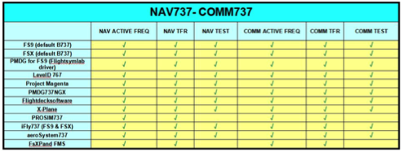

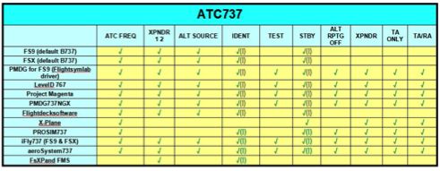

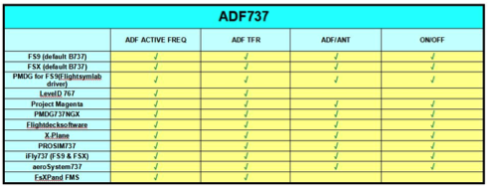

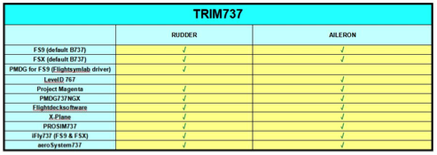

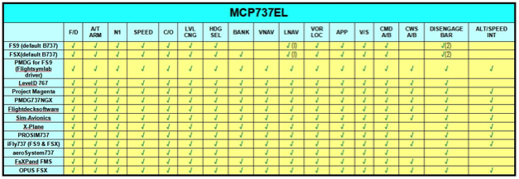

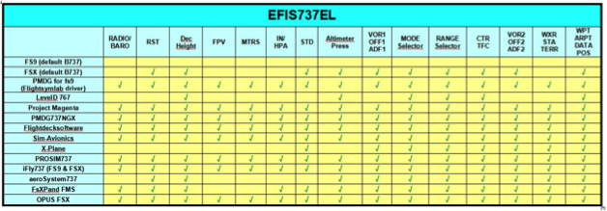

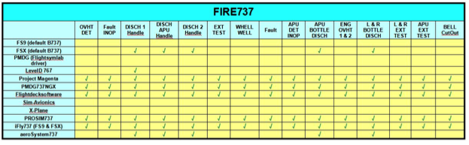

1. The size of the panel holes dictated the use of the SimWorld switches as there is insufficient clearance in a number of positions for ordinary switches.
2. Fly engavity
3. Open Cockpit Annunciator are better finished than the SimWorld units. Simworld need a coat of black paint around the edges to finish them.